# Depth-first Search(DFS)

DFS searches deeper in the graph. It explores edges for each found vertex when it finds it.

When all ’s edges have been explored, it “backtracks” to explore edges living the vertex from which was explored

It starts from a vertex, discover all its edges, proceeds recursively on all adjacent vertices which have not been discovered yet

It keeps track of the process by colouring vertices

* White vertices have not been discovered yet
* Grey vertices have been discovered but not totally explored
* Black vertices have been totally explored— if (u, v) ϵ *E* and *u* is black, then *v* is not white

Additionally, DFS records when it discovers vertex *u* by setting setting a timestamp

* *u.d* records the time when *u* becomes grey
* *u.f* records the time when *u* becomes black
* For each vertex *u.d < u.f*

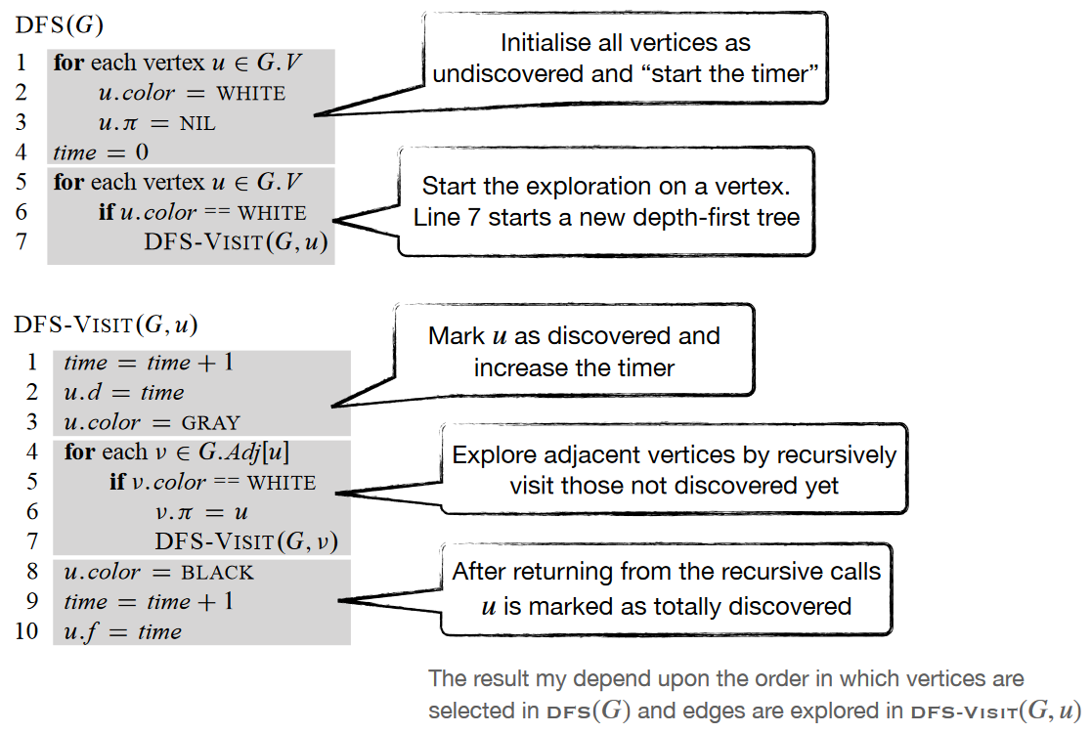

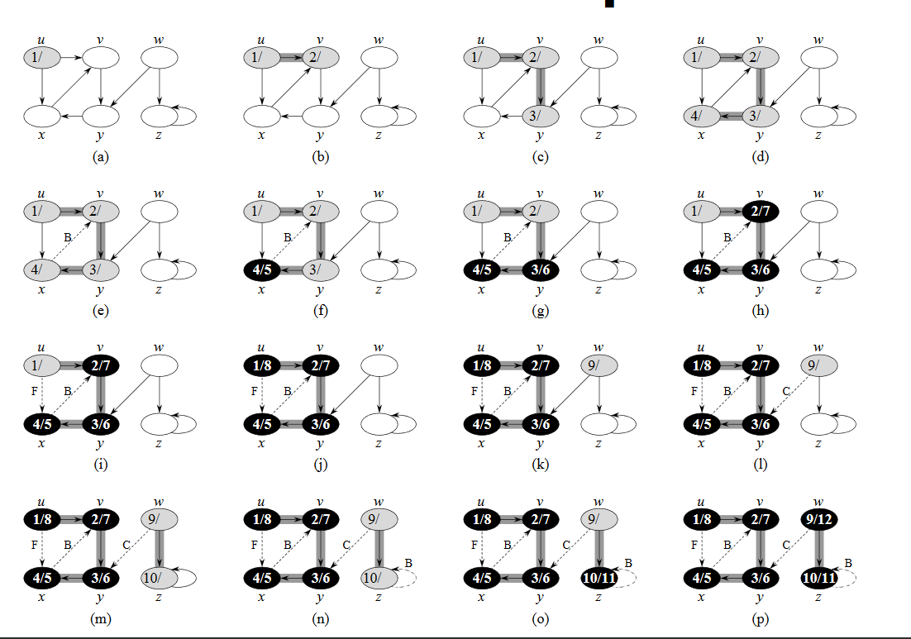

Dotted paths are ignored, as the vertex is already discovered(grey). The algorithm backtracks and sets the vertex to black.

DFS runtime is 